## What is Amazon CloudWatch?

## Amazon CloudWatch is an observability and monitoring service offered by AWS. It allows you to gather and track metrics, collect and monitor log files, set alarms, and respond to changes in your CloudWatch in AWS resources.

**What is Amazon CloudWatch?**

AWS CloudWatch is made up of two distinct services that are:

1. **Metrics:**  
   This service records and manages resource performance and operational metrics. It captures and stores resource metric data and provides dashboards, event filtering, and alarms.
2. **Logging:**  
   This service captures, stores, and manages service and application logs. It offers log data capture, storage, and archiving and an essential log viewer and query capability.

The below figure can explain these two different services.

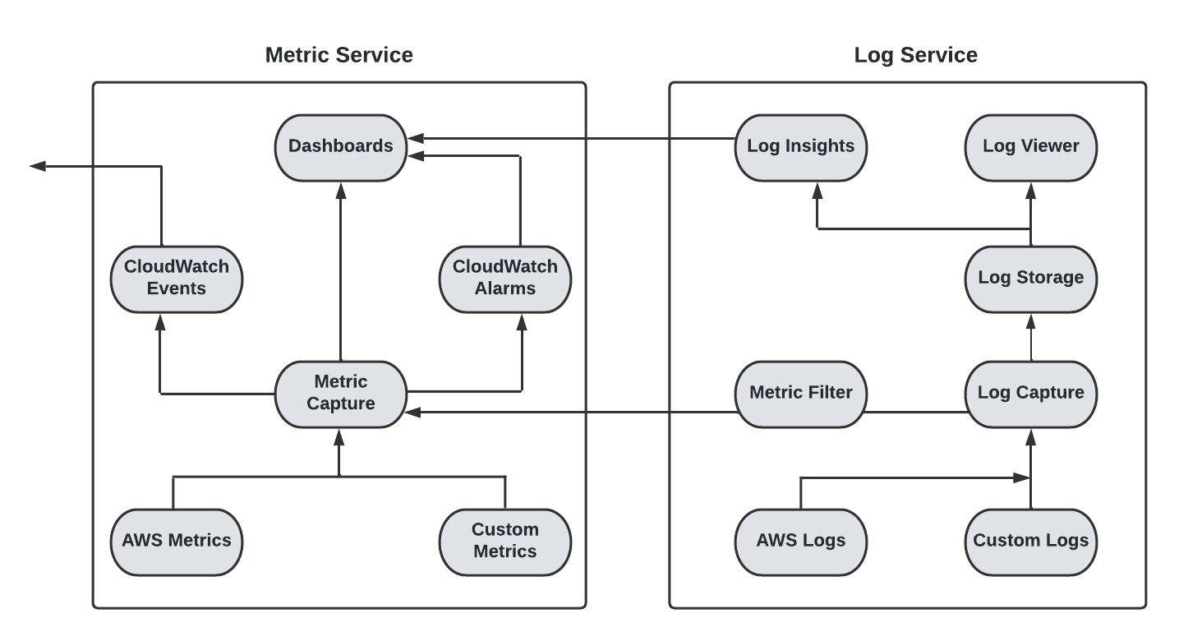

Amazon CloudWatch enables developers and administrators to monitor their AWS applications in near-real-time. CloudWatch automatically provides statistics on request counts, lag, and CPU utilization. Users can also send logs and personalized metrics to CloudWatch for monitoring.

**Amazon CloudWatch terminology**

Here are the terminologies of CloudWatch:

1. **Metrics:**  
   **Metrics are the fundamental concept in CloudWatch. A metric represents a time-ordered set of data points that are published to CloudWatch. Think of a metric as a variable to monitor, and the data points as representing the values of that variable over time.**
2. **Statistics**:  
   **Statistics are metric data aggregations over specified periods of time. When you graph or retrieve the statistics for a metric, you specify the Period of time, such as five minutes, to use to calculate each statistical value.**
3. **CloudWatch Alarm**:  
   **Cloudwatch alarm is used to monitor a single cloud watch metric or the result of Match expression using cloud watch metrics. Also, it sends out a notification based on the threshold we set for each service in the cloud watch alarm.**
4. **How many CloudWatch alarms can I have?**

No limit on the total number of alarms per account. Alarms based on metric math expressions can have up to 10 metrics. 200 Metrics Insights alarms per Region. You can request a quota increase .

1. **Dimensions**:  
   Dimensions are a name/value pair that uniquely identifies a metric. They are unique identifiers for a metric that help you add a unique name/value pair to one of the metrics.
2. **CloudWatch dashboard**:  
    **Amazon CloudWatch dashboards are customizable home pages in the CloudWatch console that you can use to monitor your resources in a single view, even those resources that are spread across different Regions. You can use CloudWatch dashboards to create customized views of the metrics and alarms for your AWS resources..**
3. **CloudWatch logs:**  
   **CloudWatch Logs enables you to centralize the logs from all of your systems, applications, and AWS services that you use, in a single, highly scalable service.**
4. **CloudWatch event:**  
   **Amazon CloudWatch Events delivers a near real-time stream of system events that describe changes in AWS resources. Using simple rules that you can quickly set up, you can match events and route them to one or more target functions or streams. CloudWatch Events becomes aware of operational changes as they occur..**
5. **CloudWatch agent:**  
   **GitHub - aws/amazon-cloudwatch-agent: CloudWatch Agent enables you to collect and export host-level metrics and logs on instances running Linux or Windows server.**

**How does Amzon CloudWatch work?**

**Amazon CloudWatch monitors your Amazon Web Services (AWS) resources and the applications you run on AWS in real time. You can use CloudWatch to collect and track metrics, which are variables you can measure for your resources and applications**.

**CloudWatch vs CloudTrail**

**CloudWatch is a monitoring service for AWS resources and applications. CloudTrail is a web service that records API activity in your AWS account. CloudWatch monitors applications and infrastructure performance in the AWS environment. CloudTrail monitors actions in the AWS environment.**

**Benefits of Amazon CloudWatch**

Here are the benefits of Amazon CloudWatch:

1. Provides insights into system performance comparisons and other relationships
2. Provides basic functions that are simple to use
3. Allows you to integrate with other AWS resources. EC2 instances are easy to integrate into asystem.
4. Improves and optimizes AWS and on-premises resource operational performance
5. Collects metrics for AWS environments efficiently;
6. Ensures stability and dependability
7. Consists of features like metrics, alarms, statics, and many more
8. Provides access to all AWS monitoring data on a single platform

**Drawbacks of Amazon CloudWatch**

Here are the drawbacks of Amazon CloudWatch:

1. Costs more than the majority of third-party monitoring and logging tools.
2. Many standard AWS metrics cannot be seen in time intervals of less than one minute.
3. The handling of unusual IP addresses should be improved.
4. AWS resources are mostly used for advanced integration.
5. More advanced CloudWatch usage can have a steep learning curve.
6. Data delays can last up to 20 minutes.

**Amazon CloudWatch Pricing**

CloudWatch has both free and paid tiers. Monitoring metrics, API requests, dashboards, alarms, log data, events, etc., are all included in the free tier.

Like other cloud services, the paid tier has a pay-as-you-go pricing structure. The number of metrics, APIs determines pricing and metric streams utilized.

There is no up-front contribution or minimum fee in a paid tier. You start paying for what you are using. And you will be billed for your usage at the end of the month.

**Frequently asked questions**

**What alarm status will trigger incidents?**

An alarm with the status ***ALARM*** will trigger incidents.

**Which platforms support CloudWatch?**

Platforms such as Windows, CentOS, Red Hat Enterprise Linux, Amazon Linux, and many more support Amazon CloudWatch.

**Does Amazon provide a metrics deletion option?**

No, Amazon does not provide a metric deletion option.

**What is a Custom Metric?**

Any metric that you provide to Amazon CloudWatch is considered a custom metric. Custom metrics, for example, track the time taken to load a web page, request error rates, or the amount of work performed by your application.

**What is CloudWatch RUM?**

Amazon CloudWatch RUM is a real-time user monitoring feature that provides insight into an application’s client-side performance in order to help you reduce the meantime to resolution.

If you want to learn more about AWS resources, you can refer to these articles: